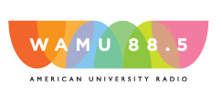

In conjunction with the tribute, Lambda lunch will sponsor one day of WAMU programming (hopefully on November 18).

Gigi Storz (Building 18T, Room 101, 301-402-0968) is collecting donations for this sponsorship

Please contact Susan Gottesman (susang@helix.nih.gov) or Gigi Storz (storz@helix.nih.gov) with questions

