Tribute
λ
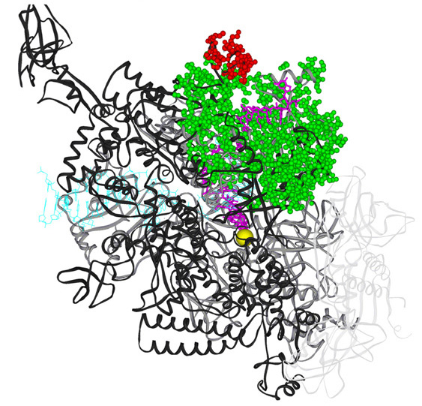

To our esteemed colleague and friend

Robert A. Weisberg
IHF

Friday, November 18

HK022
1:30 – 5:00 pm

Presentations from 2:00 – 4:00 pm Reception from 4:00 – 5:00 pm

Cloister (Building 60) on the NIH campus

Location of Building 60
